THE FALL OF QIN DYNASTY IN CHINA

Student’s Name
Subject
Professor
Date

Qin Empire established itself as one of the most powerful dynasties in the 19TH and the 20TH century. Despite its emperors having a hand its downfall, internal and external conflicts took a toll on its development. Notably, the European conquest in the Asian continent was instrumental in the fall of the dynasty. Also, during its downfall, the empire was characterized by a series of rebellions that fueled civil tension. Corruption and power struggles marked the internal infrastructure of the dynasty. Collectively, the decline of the empire became inevitable. The purpose of the paper is to analyze internal and external strife within the different Qing regimes. The paper, therefore, provides a conceptual framework on the implications internal and external conflicts had on the fall of the Qin dynasty
Qin dynasty was the last ruling family in China that was faced out between 1911- 1912. The dynasty reigned for the longest time in the history of China. Also, the imperial rule by the dynasty was a force to reckon with as they used excessive force in the conquests. The fall of the dynasty is contributed to both internal and external forces. The epitome of the civil strife was marked with the Lotus Rebellion that emerged due to the power struggles between the indigenous population and the migrants. Also, the fall was compounded by the imperial mistakes the ruling class made. They propagated the Qin supremacy by imposing trade restrictions on European countries like British. The British were thirsty to colonize the Asian led to the dynasty losing some of its peripheral regions like Hong Kong. Collectively, these factors led to the fall of the dynasty.
The Summer Palace: Cixi and the Decline of the Qing Dynasty Movie
The movie is about the Empress Dowager Cixi who was the supreme majesty of the dynasty between the years 1861- 1908. The emperor rose to power after the demise of emperor Xianfeng. The queen was a European sympathizer; as a result, it was the pioneer of the Chinese revolution. Her reign was not short of revolutions, which took a toll on her administration. The movie revolves around the empress, Cixi, who was a concubine who managed to maneuver the wheels of power to her advantage. She succeeded in her conquest motives since she had given her first son to the emperor. She started the Xinyou Coup within the palace to ensure that her son rose to power. Her supremacy led to the rebuilding of the Summer Palace and steered the dynasty towards remarkable civilization. The Summer Palace symbolized a centralized government that diplomatic activities took place. Despite the magnificence of the palace, it also bred opposition that would later destroy the palace.
The opposition sparked a revolution that hindered the reforms. Consequently, the palace lost its political powers. Notably, the Second Opium War crippled the dynasty led to the capture of her capital Beijing. The war created leadership gap with the dynasty short of leaders to make important decisions. The corruption of the royal family together with the resistance from the Han people threatened her position.
She realized that in order to establish stability within the empire, she had to exert more power than her husband. Consequently, the empire gradually resurged. She did this by consolidating her administration to reduce corruption within the official circles. The officials propagated corruption through trickery to satisfy their personal motives especially among the Hans. She coordinated with the western countries against her will to restore the economic sustainability of her empire. The onset of the decline of the Qing dynasty is evident during the Sino-Japanese war where she was defeated. However, she was not remorseful; instead she threw a royal party with her officials. She also lost the Battle of Yalu River as she signed the Treaty of the Shimoneski at the disbelief of her subjects. It is evident that that the decline of the dynasty was as a result of corruption, internal, and external resistance.
Fall of Ming Movie
The “Fall of Mings” movie narrates the Ming dynasty under the reign of Chongzhen. The dynasty experienced major setbacks from the constant rebellion and the disease outbreak. The emperor ‘s efforts to contain the epidemics were futile. The Ming dynasty ushered the Qing Empire and drew parallelism to its successor since it was plagued with rebellions. Notably, the notorious rebel known as Li Zicheng troubled Chongzhen’s administration. His rebel activities lead to the emperor sending his General, Sun Chuating, to quell the opposition. Chongzen like Cixi was forced to restore calmness within his empire by fighting the opposition.
The theme of the movie recreates the ancient dynasties that experienced almost similar downfalls. The military battles experienced drawbacks due to inadequate financial support. Moreover, they were weakened by an epidemic which swept almost the entire barrack. The commander was adamant that informing the troops on the how the disease was spread would cause chaos. Dr. Zhao who made a breakthrough on spreading mechanisms of the disease died after contracting the same. Corruption is also evident in his reign when the commander is forced to ransack the houses of the governors to retrieve food and money. He conducted the operation to accumulate the money necessary to reinforce his military force. The dynasty is struggling under the clinch of corrupt officials. For instance, the registry together with its official disappeared in a mysterious fire. The fire was to the one that had grazed down the grain and cotton stores during the periods of inspection.
The relationship between the administration and the civilians worsened sparking civil uprising and mass demonstrations. The civil strife only intensified the tensions in the empire since many civilians were murdered as the emperor ruled with impunity. He employed excessive force to calm civil tensions. The farmers where unfairly denied the rights to own pieces of land within the empire. Consequently, the economy deteriorated and there were rapid deaths as a result of famine. The emperor was defeated at the Battle of Shanhal Pass when the Wu Sangul and the Manchu Prince Dorgon joined forces against a common oppressor. Eventually, Chongzhen committed suicide by hanging himself on a tree. It is evident from Chongzhen’s reign that opposition from the Chinese peasant against poor leadership would lead to the fall of the dynasty. The sequence of events indicated that the Qing dynasty would be met with similar fate as its predecessors.
Figure 1: War- Qing’s Relations with the Western World
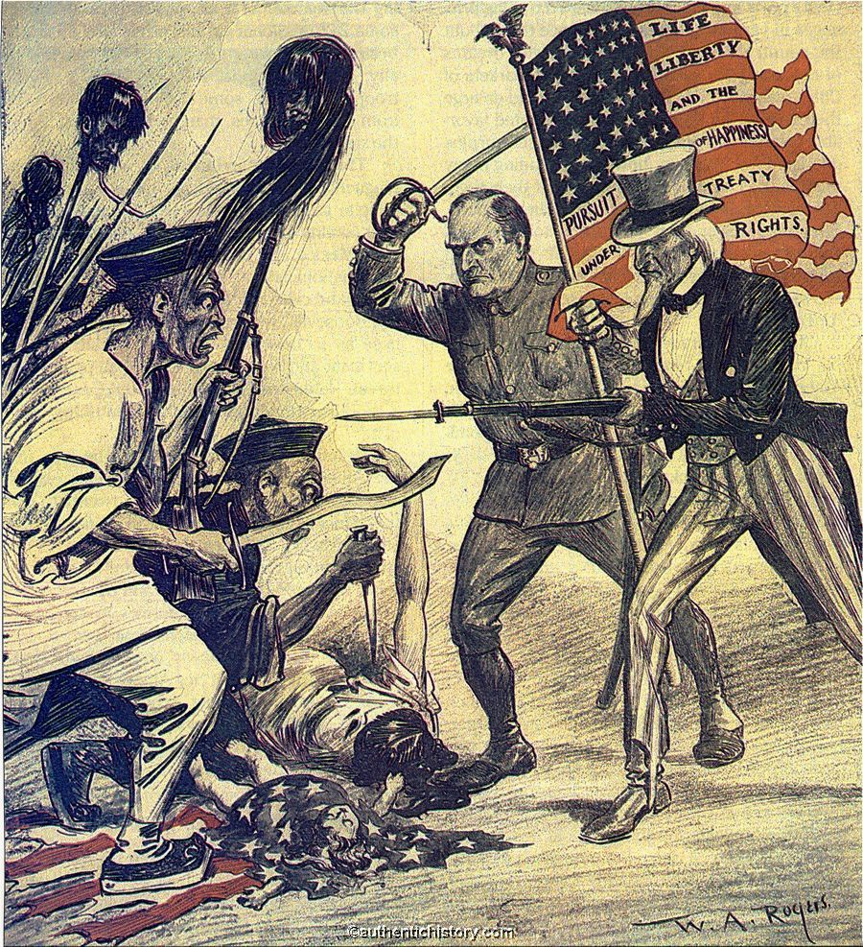
Source: Word Press: Qing’s Relation with the Western World
The Qin dynasty poor relationship with the outside world led to the Xinhai Revolution in 1911. The Chinese lost to the British during this the first and the second Opium War. Countries like France made treaties with neighboring states like Japan forcing China to open its doors to westernization with the aim of being industrialized. The partnership with the western countries gave rise to inequalities in trade since they assumed monopoly of the Chinese markets. The Qing dynasty had financial constraints and remained in these partnerships to sustain the empire economically. The approach presented inadequacies that led to the emergence of the Boxer rebels. The rebels attacked the British missionaries and vandalized Western infrastructure within the empire. For instance, they held captive the Westerners for 100 days before their governments came to their aid. The image validates the notion that the Qing dynasty collapsed due to both external and internal mutiny.
The Last Empress
“The Last Empress” is a book is about emperor Dowager Cixi who marked the end of the Qing dynasty. She was the widow of Emperor Xianfeng, she ruled between 1851- 1861 and handed power to her young son Tongzhi who ruled from 1861- 1874. She tried to modernize the empire by allowing the Western influence in an attempt to carry out radical reforms. The regime was characterized with power struggles between her and Guangxhu who was her nephew. Guangxhu solicited support from the general of the military force to overthrow his aunt from power. The internal strife is aggravated when the general betrays Guangxhu and arrested him under the direction of Cixi. The accomplices of Guangxhu within the palace were executed by the emperor. The book depicts numerous royal conspiracies by the officials to overthrown Emperor Cixi. The attempts streamline with the internal conflicts in the movies “Fall of Ming” and the “The Summer Palace: Cixi and the Decline of the Qing Dynasty”
In conclusion, internal and external strife played an important role in the fall of the Qing dynasty in equal measures. The selfish motives of both the royal family and officials lead to poor governance that sparked rebellions among the civilians. The dynasty also struggled with conflicts from British, France, and Japan.

Bibliography
,Anchee, Min. "The Last Empress". Empire Crumble, Hearts Are Broken 6, no. 1 (1990).
Kuo, Kaiser. "Kuora: The 1911 Xinhai Revolution And Birth Of Modern China - Supchina". Supchina, Last modified 2018. https://supchina.com/2018/10/08/kuora-the-1911-xinhai-revolution-and-birth-of-modern-china/.
"Learn The Cause Behind The Fall Of China's Qing Dynasty". Thoughtco, Last modified 2018. https://www.thoughtco.com/fall-of-the-qing-dynasty-195608.
"Movie "Fall Of Ming" Alludes To The CCP's End". Youtube, Last modified 2018. https://www.youtube.com/watch?v=MWsSTWmF1_Q.
"Redirect Notice". Google.Com, Last modified 2018. https://www.google.com/url?sa=i&source=imgres&cd=&cad=rja&uact=8&ved=2ahUKEwib0OamltveAhXIzIUKHYlfBUMQjRx6BAgBEAU&url=https%3A%2F%2Fgharbiyeho.wordpress.com%2Fcategory%2Fwar%2F&psig=AOvVaw1LNZrkdi20WWE7_Mdy61H5&ust=1542535401351548.
"The Summer Palace : Cixi And The Decline Of The Qing Dynasty - Screener". Youtube, Last modified 2018. https://www.youtube.com/watch?v=ck9i5kPKqgo.
Zhang, Zhang. Cixi And Modernization Of China.. Berkeley, Calif.: Asian Social Science, 2008.

"Movie "Fall Of Ming" Alludes To The CCP's End", Youtube, Last modified 2018, https://www.youtube.com/watch?v=MWsSTWmF1_Q.
"The Summer Palace: Cixi And the Decline of The Qing Dynasty - Screener", Youtube, Last modified 2018, https://www.youtube.com/watch?v=ck9i5kPKqgo.
"Movie "Fall of Ming" Alludes to The CCP's End", Youtube, Last modified 2018, https://www.youtube.com/watch?v=MWsSTWmF1_Q.
Kaiser Kuo, "Kuora: The 1911 Xinhai Revolution And Birth Of Modern China - Supchina", Supchina, Last modified 2018, https://supchina.com/2018/10/08/kuora-the-1911-xinhai-revolution-and-birth-of-modern-china/.
Kaiser Kuo, "Kuora: The 1911 Xinhai Revolution And Birth Of Modern China - Supchina", Supchina, Last modified 2018, https://supchina.com/2018/10/08/kuora-the-1911-xinhai-revolution-and-birth-of-modern-china/.
Min ,Anchee, "The Last Empress", Empire Crumble, Hearts Are Broken 6, no. 1 (1990).
Zhang Zhang, Cixi And Modernization Of China. Berkeley, Calif.: Asian Social Science, 2008.
"Learn The Cause Behind The Fall Of China's Qing Dynasty", Thoughtco, Last modified 2018, https://www.thoughtco.com/fall-of-the-qing-dynasty-195608.
"Redirect Notice", Google.Com, Last modified 2018, https://www.google.com/url?sa=i&source=imgres&cd=&cad=rja&uact=8&ved=2ahUKEwib0OamltveAhXIzIUKHYlfBUMQjRx6BAgBEAU&url=https%3A%2F%2Fgharbiyeho.wordpress.com%2Fcategory%2Fwar%2F&psig=AOvVaw1LNZrkdi20WWE7_Mdy61H5&ust=1542535401351548.
Zhang Zhang, Cixi And Modernization Of China. Berkeley, Calif.: Asian Social Science, 2008.

